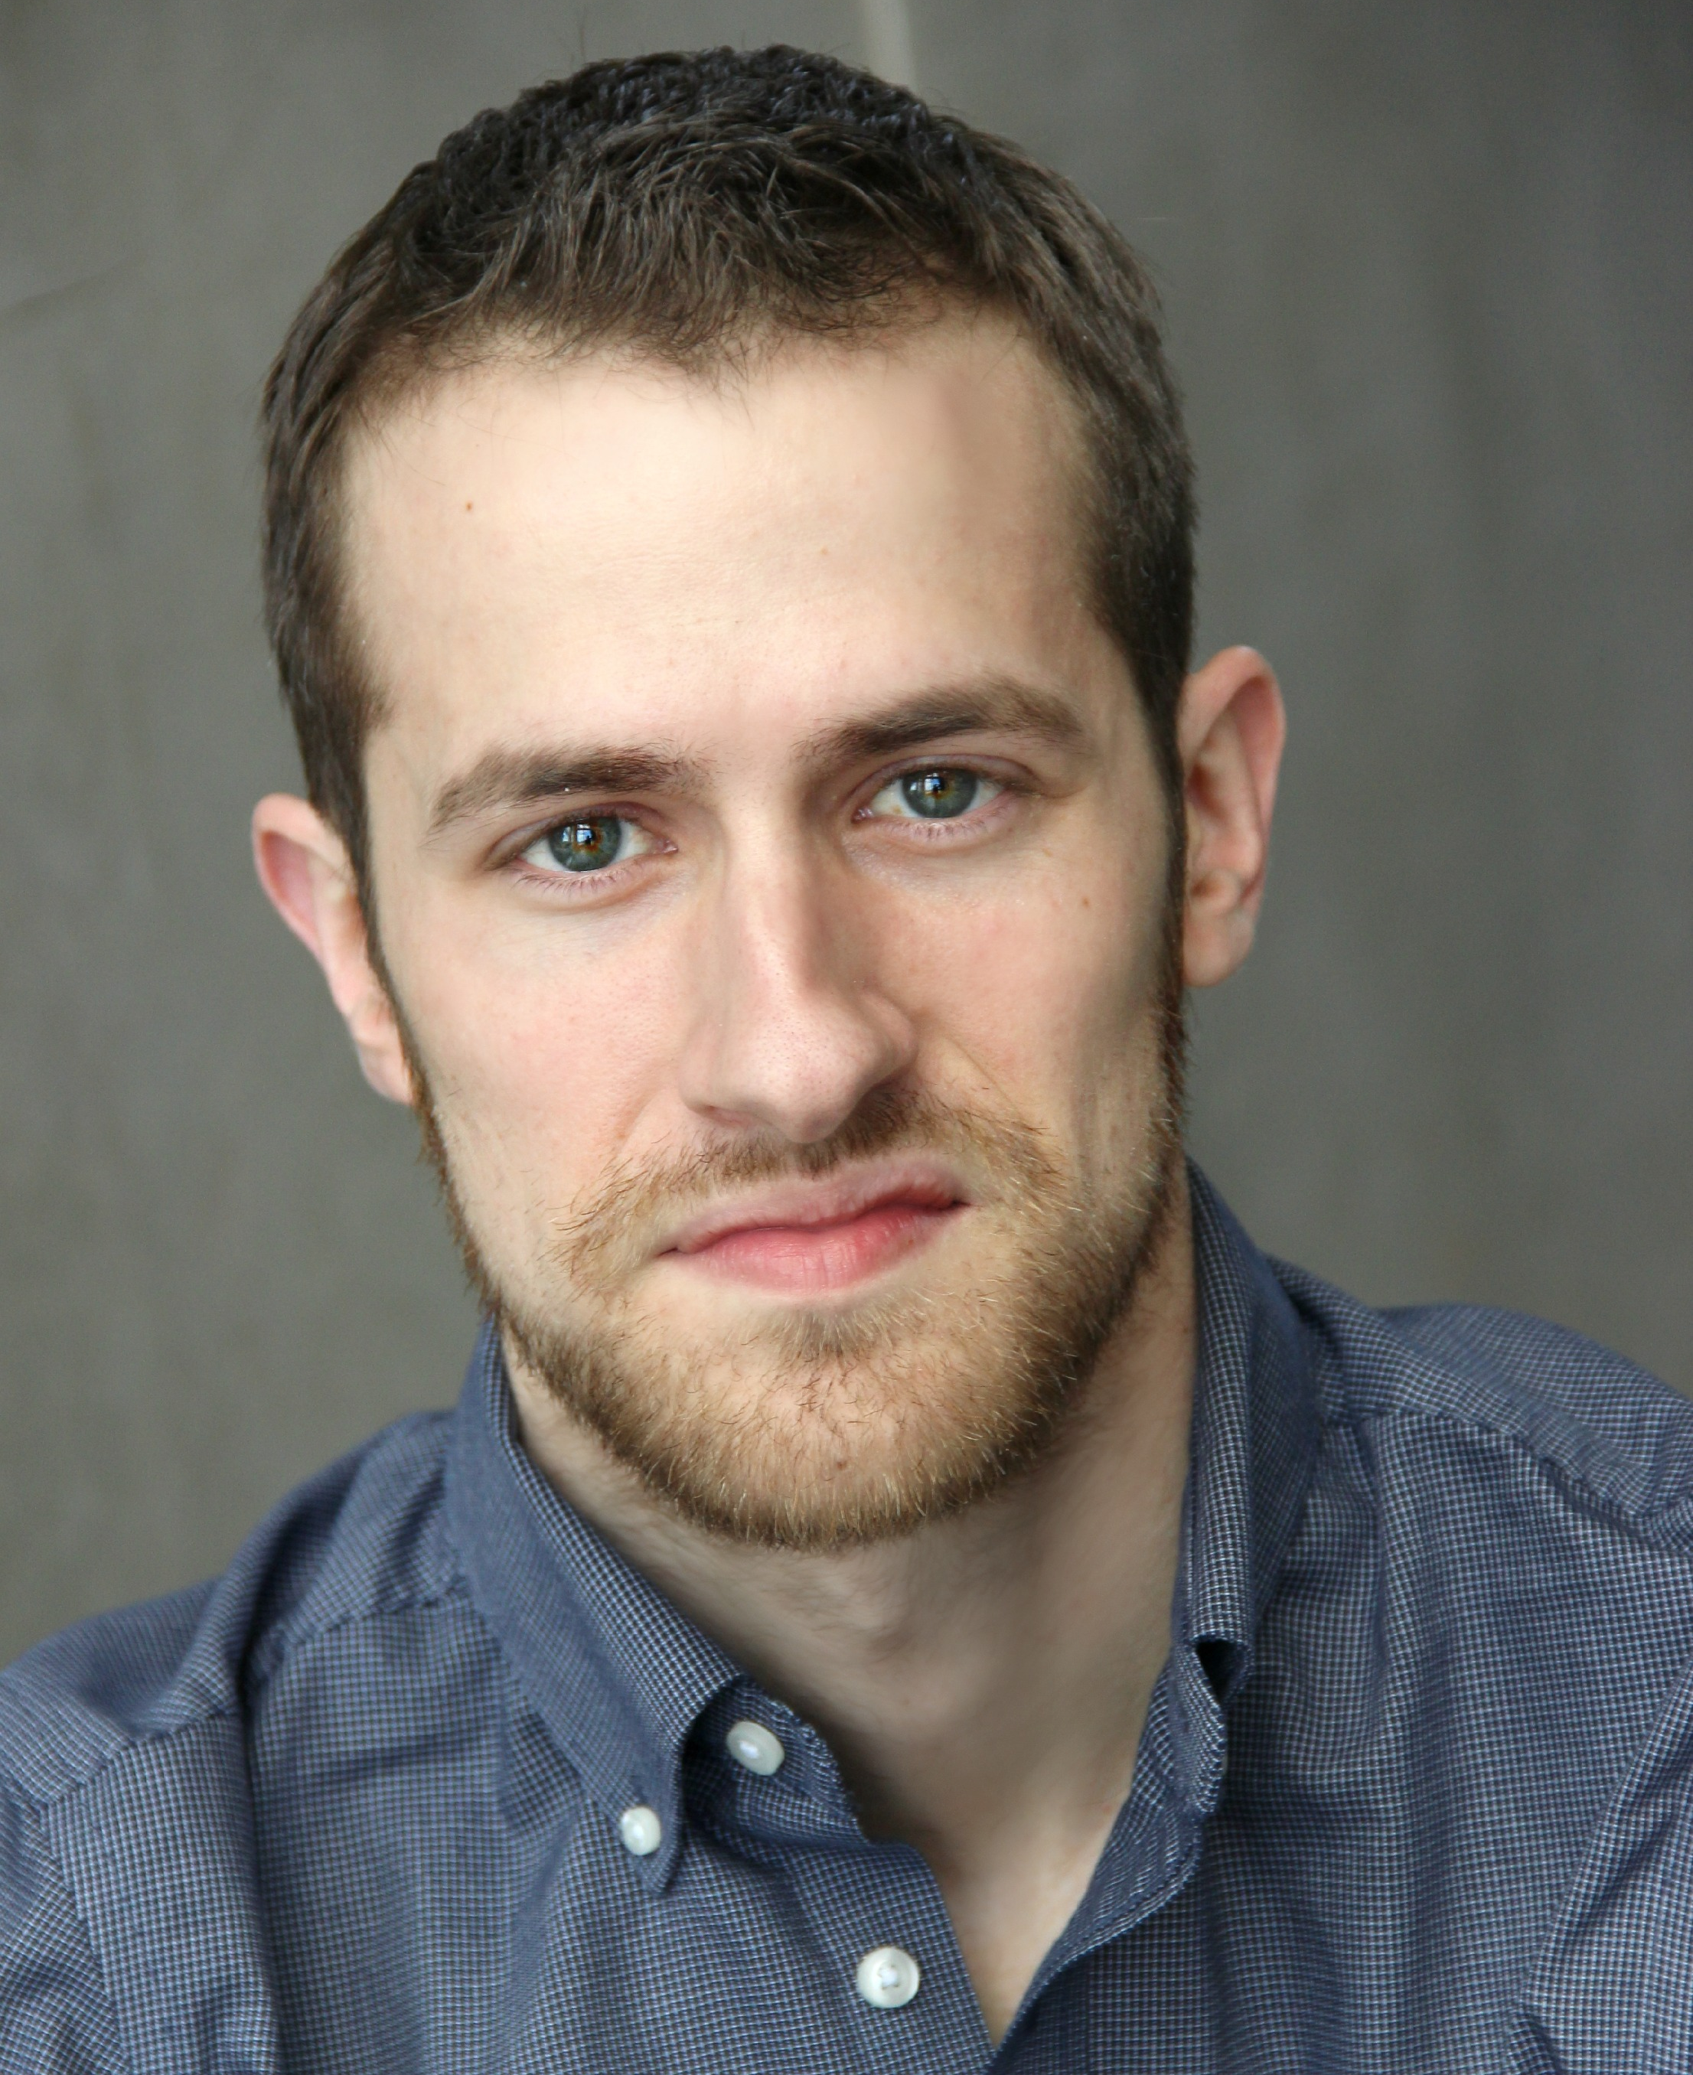
Erik Meixelsperger

erikmeixels@gmail.com
(913)742-3315

theater
Double Indemnity  Oedipus Rex  The Rehearsal  Much Ado About Nothing  The Break Of Noon  Mary Poppins  Mary Poppins  Spoon River Anthology  A Dolls House | Walter Huff  Kreon  Damiens  Dogberry  John Smith  Bert  Bert  Various Roles  Krogstad | Dog Days Theatre Company  FSU/Asolo Conservatory  FSU/Asolo Conservatory  FSU/Asolo Conservatory  Stage 2 Theatre Company  The White Theatre  The Theatre In The Park  University of Minnesota Duluth  University of Minnesota Duluth
Buried Child | Vince | University of Minnesota Duluth
Detestable Madness | Callimachus | University of Minnesota Duluth
Legally Blonde: The Musical | Dewey/Nikkos | University of Minnesota Duluth
La Culebra | Coyote | Johnson County Community College
A Devil Inside | Brad | Johnson County Community College
Godspell | Max | Johnson County Community College
Richard III | Ratcliffe | Johnson County Community College
Equus | Alan Strang | Johnson County Community College
film/radio
Quintiles | Voice Over | Dawn Miller
training
Master of Fine Arts Candidate- Florida State University/Asolo Conservatory
Bachelor Of Fine Art In Acting- University Of Minnesota-Duluth
Stage Combat Certification | Robert Westley (Unarmed)
special skills and awards
Irene Ryan Finalist (Kennedy Center ACTF 2016)
Irene Ryan Finalist and 1st Alternate Recipient (Kennedy Center ACTF 2012)
Irene Ryan Semi-Finalist (Kennedy Center ACTF 2011)
Juggling
Guitar
Advanced Tap Dancing

